Simultaneous Operations
Simultaneous Operations (SIMOPS) is defined as two or more work scopes during occurring simultaneously in the same or adjacent areas, or the same or associated systems.
The Simultaneous Operations Decision Matrix (SIMOPS Matrix) is a quick reference tool to determine if activities can be performed simultaneously.
The SIMOPS Matrix must be used in conjunction with the associated Task Definitions and Restriction Tables.
Each fabrication site should develop its own Task Definitions, SIMOPS Matrix and Restrictions Table, including regulatory requirements or unique operational aspects specific to the location.
Deviation from the guidance provided by the SIMOPS matrix or Decision Tables requires approval from the appropriate level of management

This toolkit consists of two parts:
- an example SIMOPS process from a Production environment (not a fabrication yard).
- Examples of fabrication site activities which could be considered for inclusion in a SIMOPS process

Example SIMOPS process
Use this flowchart to determine what interaction, if any, two simultaneous activities may have as defined by the SIMOPS Matrix.
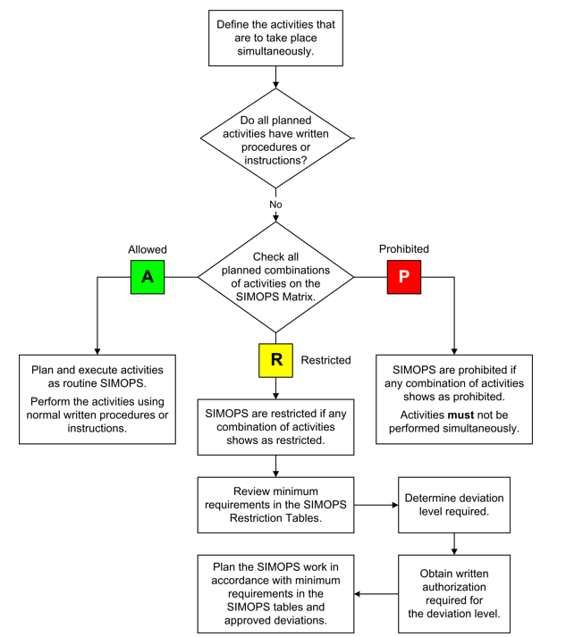
Refer to task definitions table
Refer to SIMOPS Matrix
Refer to Restrictions Table

Example of SIMOPS task definitions table
Term | Example of a definition – fabrication site to write its own
abrasive blasting | High-velocity air that is carrying sand or other abrasive particles to clean metal surfaces.
bypassing | Preventing a safety device or safety equipment item from completing its design function.
Coating Operations (activities) | Any activities to remove coatings from, or place coatings onto equipment. Coating activities include:  - Spray painting  - Abrasive blasting  - Installing insulation, such as fiberglass
designated safe welding area | An area at the facilities, pre-approved by management  that does not require special preparation to provide  isolation either horizontally or vertically from hazardous areas to allow hot work.
engine-driven  equipment and vehicles | Any equipment powered by an internal combustion engine  including vehicles. These items are a potential  source of ignition and exhaust gas emissions  contain carbon monoxide that is hazardous for  a confined space atmosphere.
hot work | Any work that creates an ignition source performed in an area which has potential for hydrocarbons or flammable materials.  Hot work includes welding, burning, gas cutting, grinding and brazing.
fire fighting system impairment | Any activity which reduces firewater availability, fire detection, availability of fire truck, fire pump, etc

Use the following steps for the SIMOPS Matrix:
- Confirm that both activities under consideration are accurately described in the Definitions Table.
- Confirm that both activities are in the same area, or same system
- Identify both activities on the SIMOPS Matrix.
- Arrive at a SIMOPS classification
- Refer to the Restriction Tables for pre-defined risk controls.
- Management Approval must be obtained to deviate from the Restrictions Table risk controls. The seniority of management required to approve SIMOPS is risk-based – the higher the risk, the higher the level of management approval.

Example of SIMOPS matrix

SIMOPS matrix classes | The SIMOPS Matrix is a chart with predefined activities showing the class of the SIMOPS to which the combination of the two activities is assigned. These classes are:
Simultaneous activities are prohibited.
They will not be performed.
No deviations are allowed.
Simultaneous activities are restricted.
The risk controls in the Restrictions Tables must be applied.
Written authorization from management must be obtained to deviate from the restriction.
 |  | Simultaneous activities are allowed using normal procedures and instructions.
 |  | Simultaneous activity combination is not applicable.

Example SIMOPS Matrix (from a Production facility)
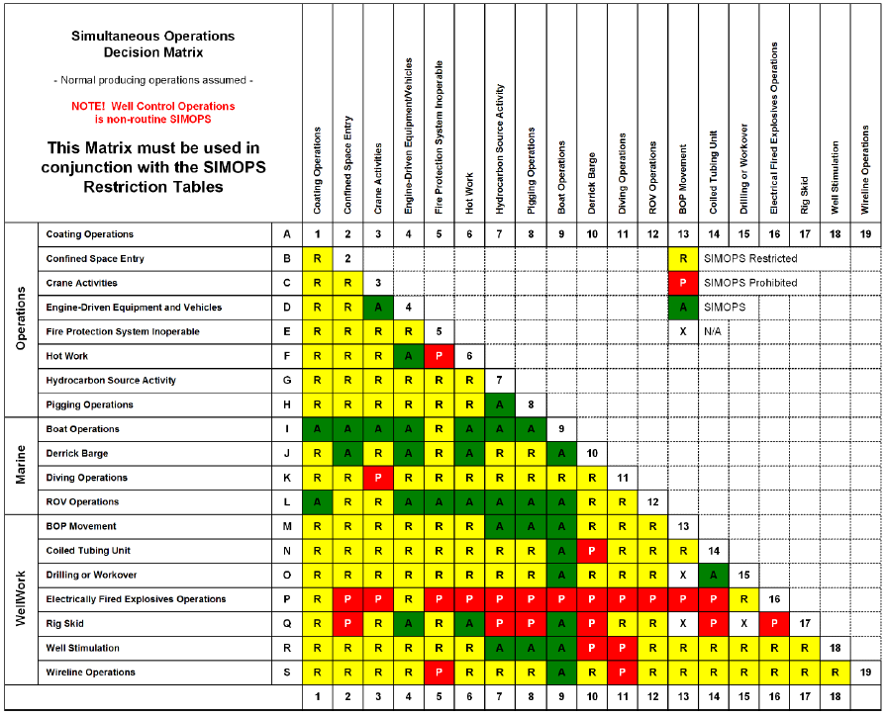

Example of a SIMOPS Restrictions Table with Deviation Approval Level
Level 1 approval = Facility Manager
Level 2 approval = Operations Superintendent
Level 3 approval = Operations Manager
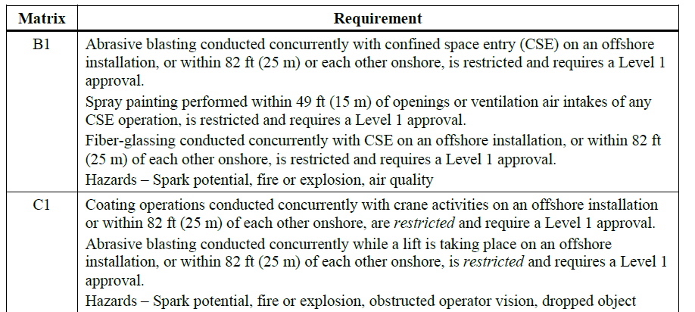

Part 2 - Activities to be considered during SIMOPS planning

A fabrication site should develop its own list of potential SIMOPS activities. These activities should be:
- Described in a Task Definitions Table
- Included in a SIMOPS Matrix (include all potential combinations of the defined activities)
- All Restricted Combinations should be included in a Restrictions Table which defines Controls required to enable SIMOPS, and the required level of approval.

Example list of potential SIMOPS activities.

- Excavation
- Hydro tests
- Insulation
- Road construction / asphalting works
- Cold work (pipe fitting, mechanical works, etc.)
- Hot work (welding, grinding, etc.)
- Scaffolding
- Painting / coating
- Lifting operations
- Electrical & Instrumentation works
- Vehicle entry
- Confined space entry
- Non destructive testing
- Moving modules
- Moving blocks
- Carrying / moving a load on a crane or forklift
Note: Fabrication sites should develop their own list of potential SIMOPS activities.

